
Goldenhill Primary Academy – Weekly Planner
‘Everyone shines at Goldenhill
Weekly Overview 6.7.26
Year Reception Summer 2

 | 8:45-8:55 | 9:00-10.15 |  |  | 10.15-10:45 | 10:45-11:00 |  | 11:00-12:00 | 12.00-12:30 | 12:30-13:15 | 13:30-13.40 |  | 14:15-15:15
MON | Reading for Pleasure |  |  | NA |  | Break-Time | NA |  |  | Lunchtime |  | NA |  | Reading
TUE | Reading for Pleasure | Maths  WARM UP: Number bonds Bing Videos  Play Number bonds game on ‘Hit the Button’. Select number bonds up to 10. Hit the Button - Quick fire maths practise for 6-11 year olds |  |  |  | Break-Time | Phonics  Lesson 52 Words ending in ing |  |  | Lunchtime |  | PE- Cosmic Yoga  3 Little Pigs  Three Little Pigs Toddler Yoga Adventure | Fairy Tale Yoga | Cosmic Kids |  | Reading
WED | Reading for Pleasure | Maths  WARM UP: Subitise to 10 Bing Videos  Subitising lesson  Subitising numbers to five | Oak National Academy |  |  |  | Break-Time | Phonics  Lesson 53 Longer words |  |  | Lunchtime |  | Geography-  7 continents of the World Bing Videos  Exploring locations - the seven continents - Years 1/2 - P2/3 - Geography Collection - BBC Bitesize |  | Reading
THUR | Reading for Pleasure | Maths  WARM UP: Counting to 100 in 1’s  Bing Videos  Using language ‘more than, fewer than’.  More than and fewer than | Oak National Academy |  |  |  | Break-Time | Phonics  Lesson 54 Longer words |  |  | Lunchtime |  | Writing a sentence about the picture.  E.g I can see a …  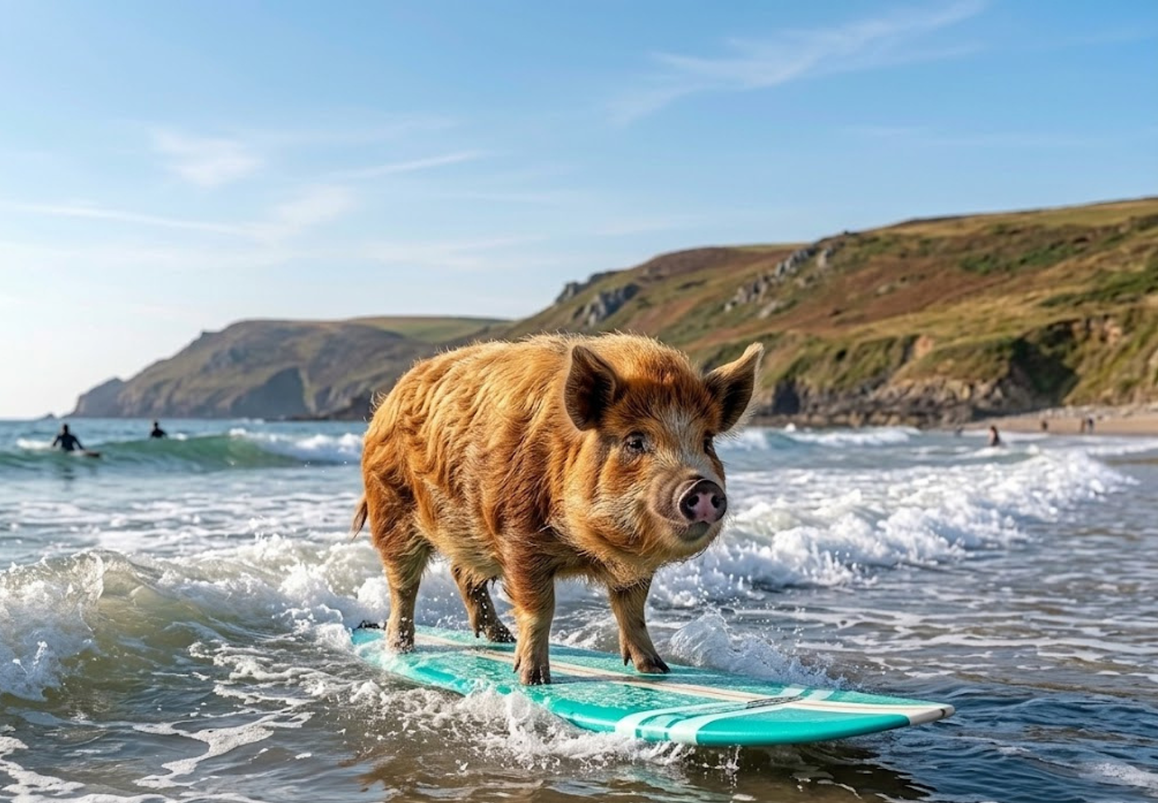  Children to spell the unfamiliar words phonetically. Encourage them to spell the tricky words correctly. |  | Reading
FRI | Reading for Pleasure |  | Maths  WARM UP: adding doubles Bing Videos  Play Doubles up to 10 on ‘Hit the Button’.  Hit the Button - Quick fire maths practise for 6-11 year olds |  |  | Break-Time | Phonics  Lesson 55 Review |  |  | Lunchtime |  | 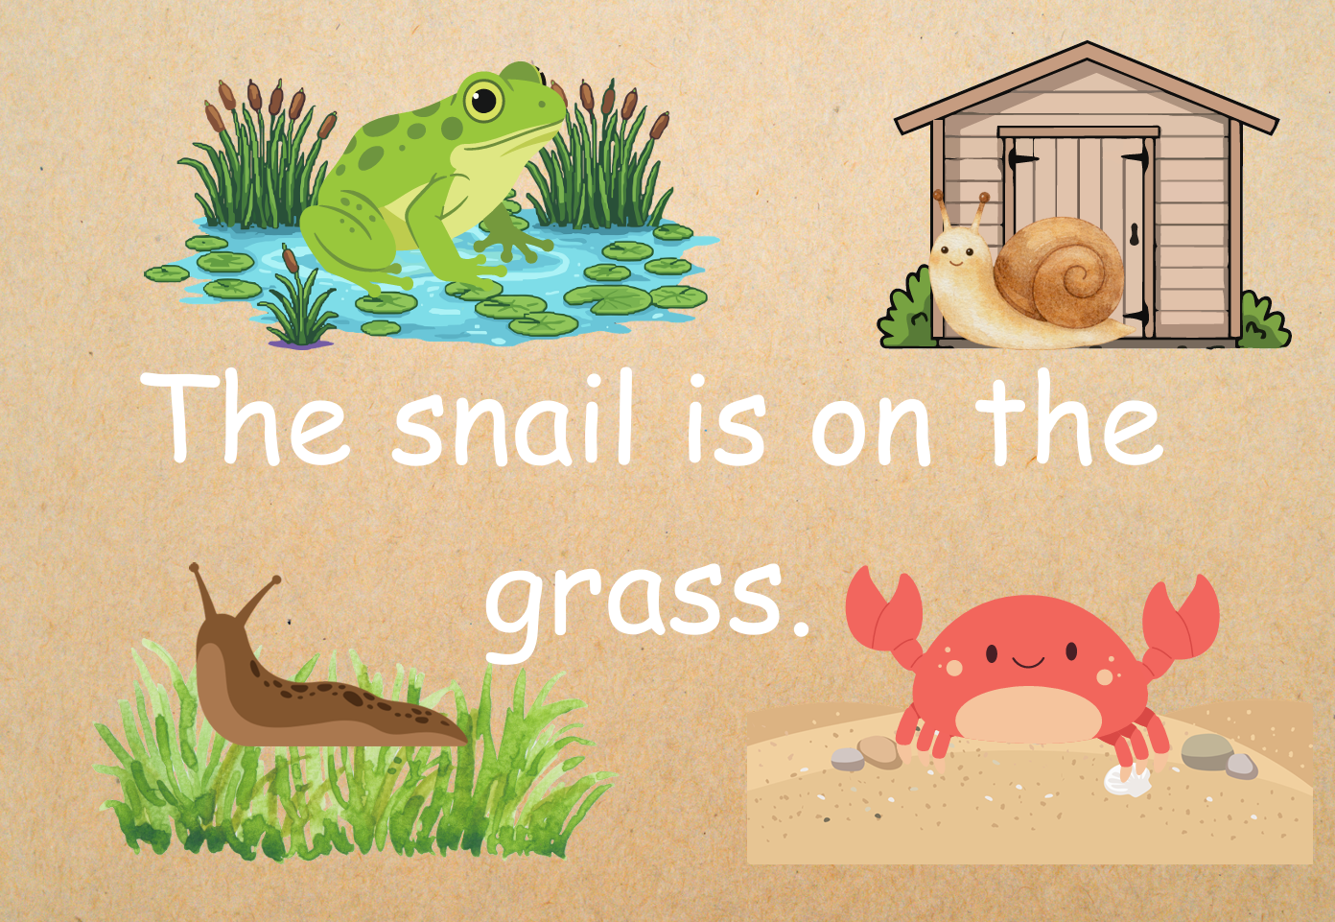  Write a sentence to describe the other animals in the picture e.g The crab is… |  | Reading

