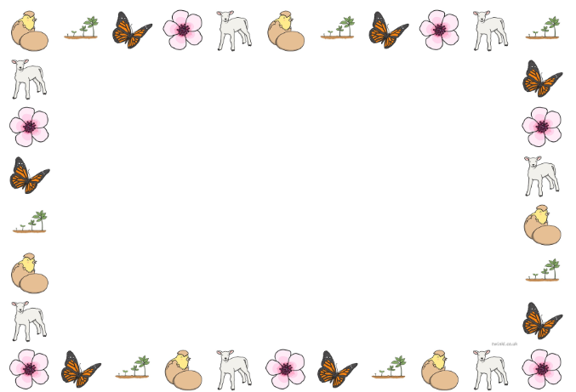
In Maths we will be:
Joining in with number rhymes and songs.
Begin to show an awareness of ten frame
To reliably count six objects with 1:1 correspondence.
To know the composition of numbers to six
To subitise to three
To know language of height and length (long, tall, short) and be able to compare
To know the language of mass (heavy, light) and be able to compare
To know the language of capacity (full, empty, half full) and be able to compare
Aware of routines and passage of time.

In Personal Social and Emotional Development, we will be:
Class rules
Why do we have Mother’s Day? How do mums help us, what do they do for us?
Looking after chicks, frogspawn, caterpillars
Keeping healthy.
Eating well
Using knife and fork and spoon to eat independently
We will be focusing on Language of co-operation and kindness
In Physical Development we will be:
Developing our pencil skills, starting to write using the correct letter formation.
Threading skills
Move in a variety of ways.
As part of P.E we will be completing a dance unit.

Signs of Spring
Nursery Class Topic Web
Spring 2 2027
In Literacy we will be:
Rhyming
Alliteration
Hearing initial sounds in words
Little Wandle Foundations for Phonics.
Blending and segmenting CVC words.
Begin to write initial sounds and CVC words.

In Expressive Arts and Design we will be:
Engage in representational play.
Explore colour and texture.
Explore play dough and clay.
Junk modelling.
Joins in with songs dancing and ring games.
Imitates in role play area.
Plays musical instruments.

In P4C we will:
Listen attentively to each other
Treat each other’s ideas with respect
Speak one at a time

In Understanding the World, we will be:
Changing seasons, Spring.
Planting seeds
Celebrating Easter.
Life cycles
In Communication and Language, we will be:

Playing in the role-play.
Using past, present and future tenses when speaking.
Learn weekly rhyme and join in with words and actions.
To say good morning/ hello/ good afternoon.

