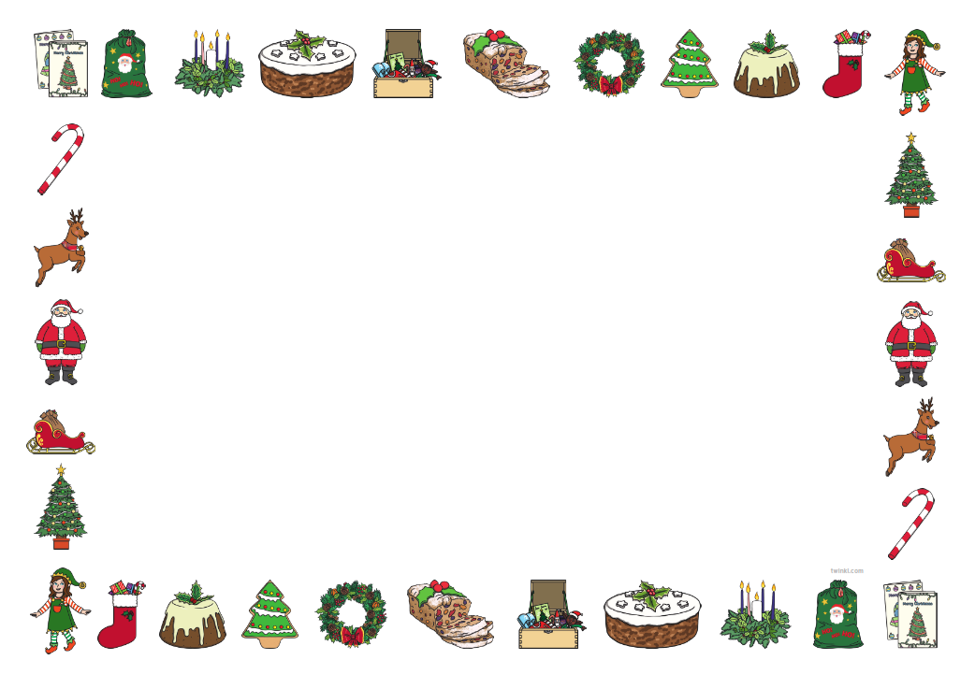
In Expressive Arts and Design we will be:
Painting
Using a variety of materials to make collages.
Using clay to create different decorations.
We will be singing

In Physical Development we will be:
Develop our pencil skills.
Use a range of tools to mould the playdough.
Begin to move in a variety of ways.
To participate in Dough Disco and Squiggle While you Wiggle.
As part of our P,E Lessons we will be focusing on the Fundamentals.

In Personal Social and Emotional Development, we will be:
Following the golden rules, classroom rules and routines.
Take turns and look after each other.
Develop relationships with our peers.
Talk about what makes us happy and sad.
Become independent with putting our coats and wellies on.
Become independent in completing hand washing routines and using the toilet.
We will be focusing on Mindfulness and Manners
In P4C we will:
Listen attentively to each other
Treat each other’s ideas with respect
Speak one at a time

In Literacy we will be:
Writing and mark making letters to Santa.
We will be listening to stories.
We will start to look at books and begin to turn pages.
We will be sequencing stories.

In Communication and Language, we will be:

Learning weekly rhyme and join in with words and actions.
To say good morning/ hello/ good afternoon.
Following instructions
Asking questions
Use verbal and non-verbal language to communicate.
Act out in the Role-Play area.
Participate in the Nativity.

Sparkle and Shine

Nursery Class Topic Web Autumn 2 2026
In Maths we will be:
Singing Number rhymes.
Counting in order
Naming numbers
Begin to make repeated patterns.

In Understanding the World, we will be:
Looking at different festivals and celebrations.
We will also compare different celebrations – birthdays, Diwali, Bonfire Night and Christmas.

