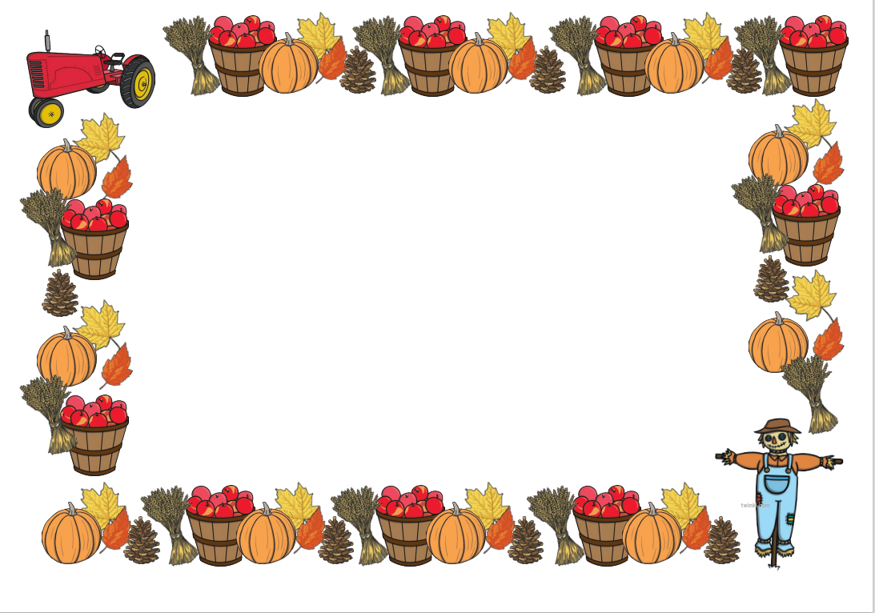
In Communication and Language, we will be:

Showing good listening, good sitting, good thinking, good speaking.
Learn weekly rhyme and join in with words and actions.
To say good morning/ hello/ good afternoon.
To respond appropriately.
Follow instructions
Ask questions
Use verbal and non-verbal language to communicate
In Maths we will be:
Join in with number rhymes and songs.
Begin to match similar objects by colour, shape, size.
Aware of routines and passage of time.

In Expressive Arts and Design we will be:
Home corner role play
Play musical instruments.
Painting
Creating collages using natural materials.
Creating self-portraits
In Physical Development we will be:
To react to stories, music and rhythm, copying gestures and movement.
To use outdoor equipment appropriately.
To develop fine motor skills developing the correct grip and strengthening fingers.
To participate in Dough Disco and Squiggle While you Wiggle.

We will be completing P.E. with a focus on an introduction to P.E.

In Personal Social and Emotional Development, we will be:
Settling in.
Learning classroom and golden rules.
To use manners
To take turns and share and play alongside others
To gain confidence and settle into Nursery.
To use the toilets in Nursery, flushing and washing hands.
To use tissues to blow noses.
To hang up, fetch and put on own coats.
To access water bottles.

We will be focusing on Self-talk and positivity

In Literacy we will be:
Learn weekly Rhyme and join in.
Begin to make marks
Identify own name.
Begin to sequence stories.
Take part in book sharing activities, listening to stories with interest. Choosing to look at books in the book corner.
In P4C we will:
Listen attentively to each other
Treat each other’s ideas with respect
Speak one at a time

In Understanding the World, we will be:
Show curiosity and interest by exploring their surroundings.
Shows curiosity about living things.
Recognises familiar places and people.
Begin to talk about home and family. Notice a change in the season.

Exploring Autumn

Nursery Class Topic Web 2026

