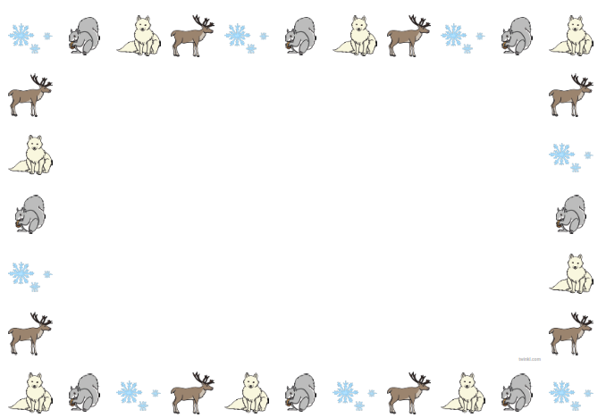
In Physical Development we will be:
Moving in different ways.
Threading skills
Pencil skills
Introducing cutting skills.
Use playdough tools.
To participate in Dough Disco and Squiggle While you Wiggle.

As part of P.E we will be completing gymnastics.
In Communication and Language, we will be:

Singing daily rhymes.
Begin to hear and say initial sounds in words.
Talk about events at home and school.

In Understanding the World, we will be:
Looking at freezing and melting, snow and ice.
Different temperatures.
Weather forecasts.
Change in seasons.
Chinese New Year.
The role of the police man. The role of the chef.

In Expressive Arts and Design we will be:
Creating collages.
Building models
Explore colours
Play musical instruments.

In Personal Social and Emotional Development, we will be:
Class rules
Having kind hands
Helping each other, what can we do to help each other in Nursery?
Naming and talking about emotions. When I feel happy ... etc.
To use the toilets in Nursery, flushing and washing hands.
To use tissues to blow noses.
To hang up, fetch and put on own coats.
To hang up and use aprons for painting and messy play.
To access water bottles.
Healthy foods
Using knife and fork and spoon to eat independently.

We will be focusing on Individual Assertiveness
Winter Wonderland

Nursery Class Topic Web
Spring 1 2027
In P4C we will:
Listen attentively to each other
Treat each other’s ideas with respect
Speak one at a time

In Literacy we will be:
Listening to stories and reading them.
Beginning to blend and segment CVC words.
Recognise and write names.
Mark making and writing to say what marks represent.

In Maths we will be:
Subitising to 3
Singing number rhymes.
Knowing the composition of numbers up to 5.

