

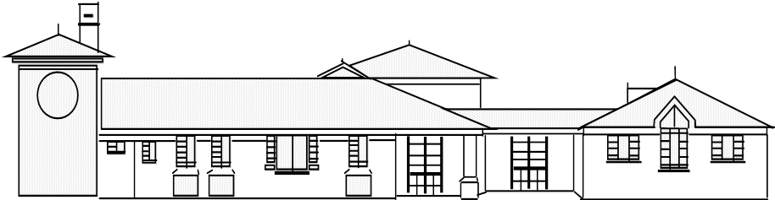
Head teacher: Mr. S Martin BA (Hons).NPQH
“Everyone shines at Goldenhill”
Broadfield Road, Goldenhill, Stoke on Trent.
ST6 4QE.
Tel: 01782 235790 Fax: 01782 235791

Goldenhill Primary Academy
part of

part of

Dear Parent/Guardian,
Welcome back!

Welcome back and Happy New Year! We hope you all had a lovely Christmas break and enjoyed spending time with family and friends. This term, our new topic is Coastlines, where we will be exploring the physical features of the coast, learning about seaside environments, and discovering how coastlines change over time. We’re really looking forward to an exciting and engaging term ahead.

- PE: This half term, the children will have PE on a Thursday and a Friday. Children should come to school wearing their PE kit on these days. For girls with earrings, these must be either removed or covered for PE sessions. We cannot provide plasters to cover earrings, these must be brought in to school. Please note that PE days are likely to change each half term- but we will keep you updated!

- Homework: The first homework grid will be given out on Friday 9th January. There will usually be two pieces of homework, and this varies each week depending on what we have been learning in class. Homework will always be a familiar subject to the children, and will be something which has already been taught. Homework is due in on Wednesdays, and children need to ensure that they pop their book inside the homework box.

- Reading: Children should bring in their reading book(s) and yellow diary every day. We will continue to encourage children to read for pleasure as much as possible and there will be time in the school day for children to read. The children move up on our Aiming High board each time they read- and will be rewarded for this.

- Children need to bring in their own water bottles with them so they can have a drink throughout the school day. These are available to purchase from the Office for a small cost. It is especially important that they bring their own bottle at this time of year, when seasonal germs are out in full force!

- Trip to Llandudno- Year 2 have a very exciting trip this term, as we will go to Llandudno on 24th March. We will have a play on the beach, have a walk around the town to spot features of a tourist seaside town and have lots of fun! Hopefully, the weather will be kind to us! Payment for this trip can be made via Arbor.

If you have any questions, please do not hesitate to ask!

Thank you for the continued support,

Miss Woodward.

