

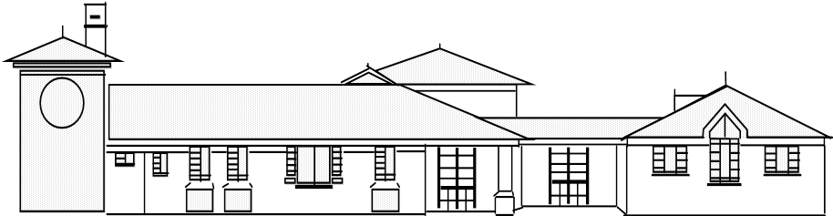
Head teacher: Mr. S Martin BA (Hons).NPQH
“Everyone shines at Goldenhill”
Broadfield Road, Goldenhill, Stoke on Trent.
ST6 4QE.
Tel: 01782 235790 Fax: 01782 235791

Goldenhill Primary Academy
part of

part of

Dear Parent/Guardian,
Welcome back!

I hope that you all had a lovely, relaxing Summer break. The children definitely needed some time to rest and recharge their batteries for our next half term. It is due to be an exciting one!
Here are some key bits of new information and some reminders for this half term:

Attached is an overview of this terms first topic and subject content. Throughout this term, your child will be learning about the topic Movers and Shakers, which will help us to learn about the lives of significant people from across the world.

- PE: This half term, the children will have PE on a Tuesday and a Thursday. Children should come to school wearing their PE kit on these days. For girls with earrings, these must be either removed or covered for PE sessions. We cannot provide plasters to cover earrings, these must be brought in to school. Please note that PE days are likely to change each half term- but we will keep you updated!

- Homework: The first homework grid will be given our on Friday 5th September. You can choose the order in which the homework tasks are completed, as long as one is completed each week. Homework books should be given in each Wednesday, and they will be handed back out on a Friday.

- Reading: Children should bring in their reading book(s) and yellow diary every day. We will continue to encourage children to read for pleasure as much as possible and there will be time in the school day for children to read. The children move up on our Aiming High board each time they read- and will be rewarded for this.

- Children need to bring in their own water bottles with them so they can have a drink throughout the school day. These are available to purchase from the Office for a small cost.

On Thursday 11th September, there will be two Meet the Teacher sessions held in the Y2 classroom. These will take place at 3.20pm and 5pm. If you cannot make either of these, information will be available on the class page following the event.

If you have any questions, please do not hesitate to ask!

Thank you for the continued support,

Miss Woodward.

