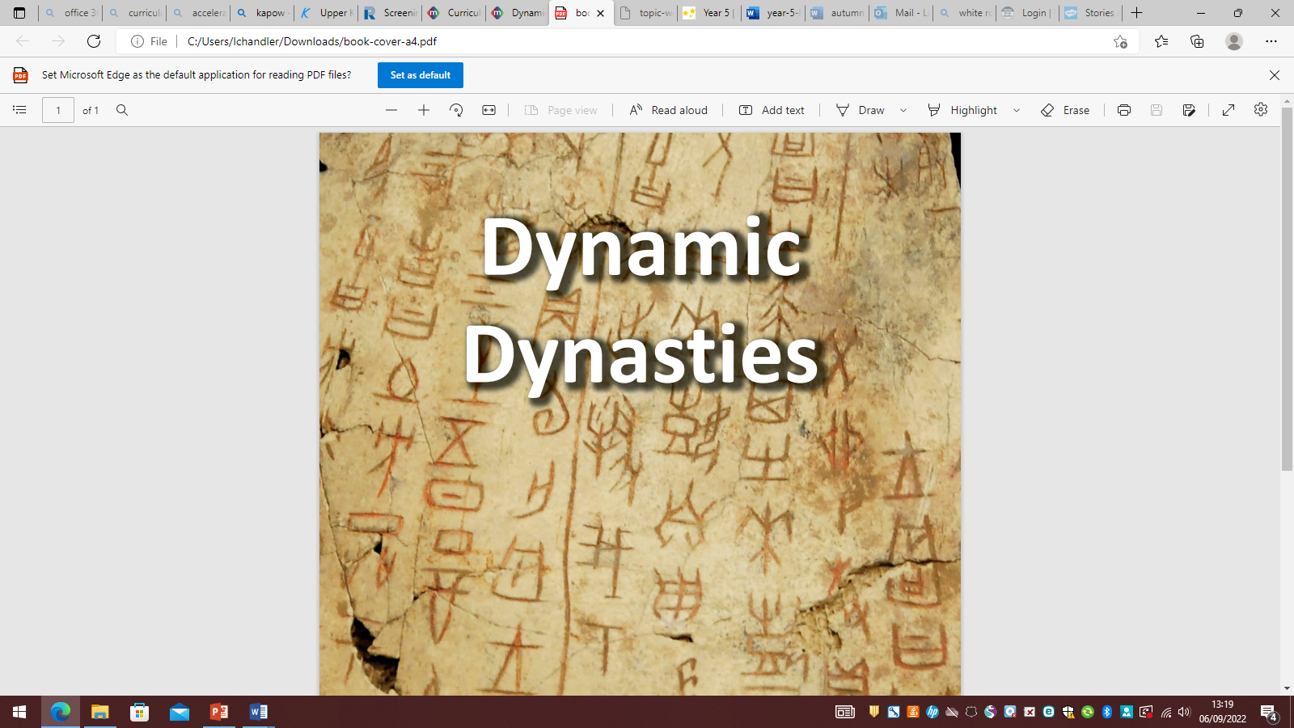
#
In Art, we will be learning about craft and design through the theme of:
- 3D Art- Interactive installations

In French we will be:
- Describing a French Monster Pet
- Learning Vocabulary related to Space
In RE we will be asking:
- Why is the Torah important to Jewish people?
- What does it mean for Christians to believe that God is holy and loving?
In P4C we will be exploring the concepts of:
Dreams vs. reality, Fairness and Music.
In PE we will be learning the skills of:
- Tag Rugby & Gymnastics
- Volleyball
In Online Safety sessions, we will explore: Online bullying and Privacy and Security In Computing we will be learning about computing systems and networks: systems and searching.
In Music, we will learn about:
- Ancient Egyptian themed composition notation.
- The history of Jazz and Blues music.

In Maths we will be covering:
- Number and Place Value
- Addition and Subtraction
- Multiplication and Division
In History we will be exploring:
- A timeline of the first five Chinese dynasties and learning about the legends surrounding the beginning of Chinese civilisation.
- The history of the Bronze Age Shang Dynasty and exploring evidence found in the ancient city of Yin.
- Oracle bones, learning about religious beliefs and explore bronze artefacts that set the Shang Dynasty apart from other civilisations.
- The hierarchy of the Shang Dynasty and discovering who was powerful and who was powerless.
- Life of the great military leader, Fu Hao.
- Significant aspects of life after the Shang Dynasty.
- Ancient China’s lasting legacy can be seen in the world today.
In Geography, we will be exploring::
- Ordnance Survey maps.
- Contour lines and revise six-figure grid references.
- How the Earth is split into 24 time zones.
- Climate zones, vegetation belts and biomes.
In English, we will be reading:
Room 13
In English, we will be:
- Practising our SPaG skills.
- Writing poetry based on the moon, and The song of Hiawatha by Henry Wadsworth Longfelow.
- Writing a series of diary entries inspired by Queen of the Falls by Chris Van Allsbury.
In PSHE we will be thinking about:
- Being Me in My World
- Celebrating differences
In DT we will be using and learning about:
- Doodlers (Electrical Systems)

In Science we will be investigating Forces and Mechanisms, including…
- Friction
- Air resistance
- Water Resistance
- Levers and Pulleys

