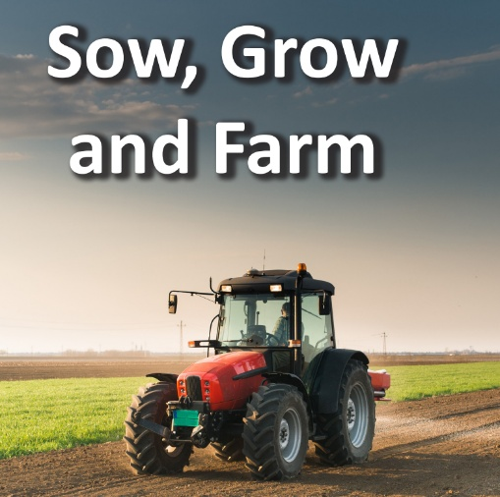
#
In French we will be learning:
- Verbs in a French Week
In RE we will be asking: U2.8 What does it mean to be a Musilm in Britain today? (Tawhid / Iman / Ibadah) Islam (Visit to Mosque)

In Geography, we will be exploring:
- Land use in the UK
- Allotments
- Farming in the UK
- Maps
- Grid references
- Climate zones
- Physical features of North and South America
- Farming in North and South America
- Food transportation
In Computing we will be learning about:
- Data and Information
- Spreadsheets
- Micro-bit
In E-Safety we will be learning about:
- Managing online information
- Self-image and identity

In Maths we will be covering:
- Multiplication and Division
- Decimals & Percentages
- Perimeter & Area
- Statistics
In DT we will be using and learning about:
- Pop up Books (Mechanisms)

In Science we will be investigating:
Earth & Space
In Music, we will learn about:
- South West & African Music

In Art, we will be learning about craft and design through the theme of:
- Drawing – Depth, emotion and movement

In PE we will be learning the skills of:
- Football, Basketball, Dodgeball, Netball
- Volleyball
In Guided Reading, we will be reading:
Kensuke’s Kingdom
In English, we will be:
- Exploring Shakespeare’s play ‘Hamlet’
- Exploring the text ‘Arthur and the Golden Rope’ and writing Myths and creating characters and settings.
In PSHE we will be thinking about:
- Dreams & Goals
- Healthy Me

