

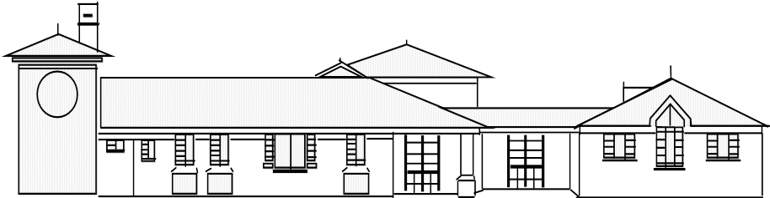
Head teacher: Mr. S Martin BA (Hons).NPQH
“Everyone shines at Goldenhill”
Broadfield Road, Goldenhill, Stoke on Trent.
ST6 4QE.
Tel: 01782 235790 Fax: 01782 235791

Goldenhill Primary Academy
part of

5/9/25

Dear Parent/Guardian,
Welcome back!

I hope that you all had a lovely, relaxing Summer break. The children definitely needed some time to rest and recharge their batteries for our next half term. It is due to be an exciting one!
Here are some key bits of new information and some reminders for this half term:

Attached is an overview of this terms first topic and subject content. Throughout this term, your child will be learning about the topic Dynamic Dynasties. In this history unit, children will learn about the people of the Shang Dynasty and their daily life, the role of Fu Hao, religion in the Shang Dynasty, and also the dramatic downfall of the Dynasty too.

- PE: This half term, the children will have PE on a Tuesday (tag rugby), and a Wednesday (gymnastics). Children should come to school wearing their PE kit on these days. For girls with earrings, these must be either removed or covered for PE sessions. We cannot provide plasters to cover earrings, these must be brought in to school. Please note that PE days are likely to change each half term- but we will keep you updated!

- Homework: The first homework grid will be given our on Friday 5th September. Homework books should be given in each Wednesday, and they will be handed back out on a Friday. This will include weekly spellings and a rotation of Maths and English.

- Reading: Children should bring in their reading book(s) and yellow diary every day. We will continue to encourage children to read for pleasure as much as possible and there will be time in the school day for children to read.

- Children need to bring in their own water bottles with them so they can have a drink throughout the school day. These are available to purchase from the Office for a small cost.

- Children may bring a healthy snack for break time.

On Thursday 11th September, there will be two Meet the Teacher sessions held in the Y5 classroom. These will take place at 3:20pm & 5:00pm. If you cannot make either of these, information will be available on the class page following the event.

If you have any questions, please do not hesitate to ask!

Thank you for the continued support,

Mrs Keay.

