

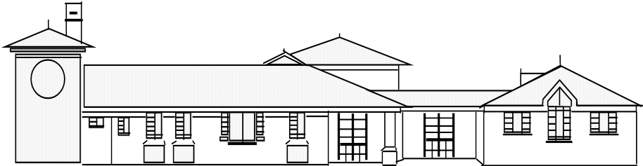
Head teacher: Mr. S Martin BA (Hons).NPQH
“Everyone shines at Goldenhill”
Broadfield Road, Goldenhill, Stoke on Trent.
ST6 4QE.
Tel: 01782 235790 Fax: 01782 235791

Goldenhill Primary Academy
part of

Welcome Back – Summer 1
Dear Parents and Carers,
Welcome back! We hope you have all had a restful and enjoyable Easter break. It has been lovely welcoming the children back into school and hearing all about their holidays. We are looking forward to an exciting half term of learning together.
Our new topic this half term is
"Big Wide World"
Through this topic, the children will explore maps, globes and digital mapping as they begin to learn about the world around them. They will discover different countries, climates, habitats, animals and foods from around the world, helping them to understand similarities and differences between places and cultures.

Enriching Their Learning
To help enrich the children’s learning, please could you provide one photograph or postcard from a holiday your child has enjoyed. Please also let us know the location and how you travelled there (for example, by car, train, plane or boat). We will then add these to our large world map for the children to explore and talk about.

Donations
To support our Big Wide World topic, we would really appreciate any donations of the following items:
- Maps or OS maps
- Jigsaw maps
- Travel guides
- Holiday brochures
- Postcards
- Language guides
- Flags from different countries
These resources will help bring our learning to life and enrich our classroom environment. Thank you very much for your continued support.

Reading
Please continue to read with your child at least 4 times a week and remember to record each read in their reading diary. Your support makes a huge difference to their confidence and progress.

Phonics
Please continue to practise the phonics sheets that are sent home each week.
If you need any further information or support with phonics, please come and see me—I’m always happy to help.

PE Information
PE will continue to take place every Tuesday.
Please ensure your child comes to school wearing their PE kit on this day.
A reminder to:
- Remove all jewellery, including earrings, before school
- Tie long hair back for safety
Thank you for your continued support.
We are looking forward to another fantastic half term together. If you have any questions, please don’t hesitate to get in touch.
Warm regards,
Charlene Sutherland

