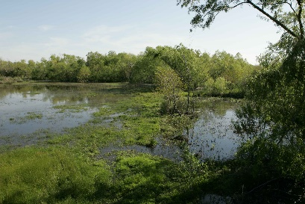 | habitat | A habitat is the place an animal lives.
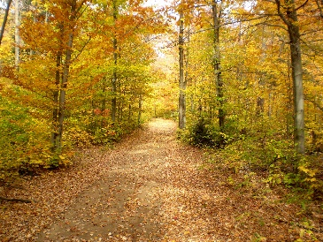 | forest | A forest has lots and lots of trees.
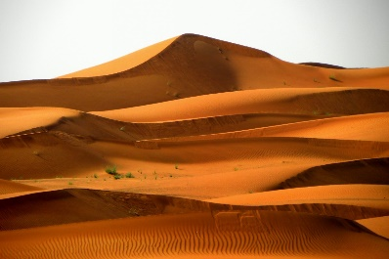 | desert | A hot, dry place with lots of sand.
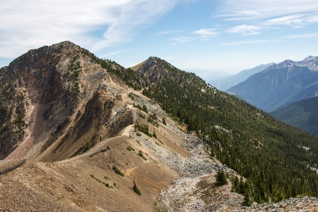 | mountain | A mountain is like a very big hill.
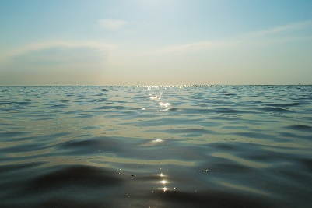 | ocean | The ocean is a large area of slat water.
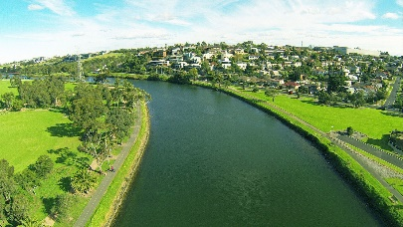 | river | Water that flows through the countryside.
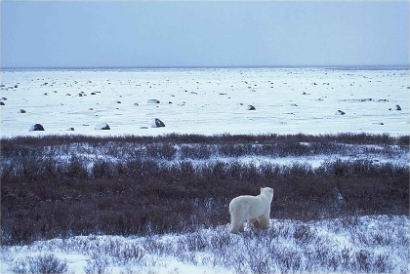 | Polar | Polar areas are icy and cold.

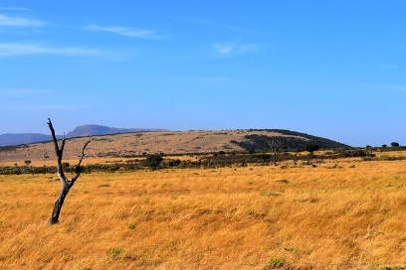 | Savannah | Open grasslands with bushes and trees.
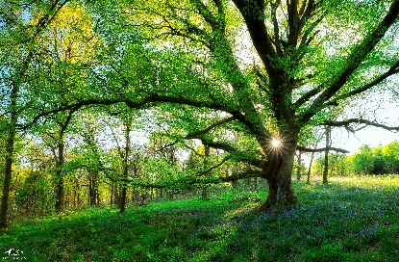 | woodland | An area with lots of trees.
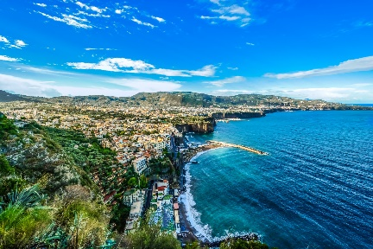 | coast | An area of land next to the sea.
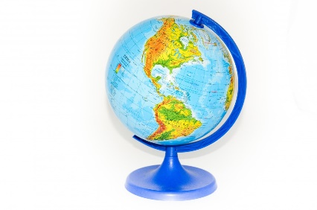 | globe | A globe is shaped like a ball and has a map of the world on it.
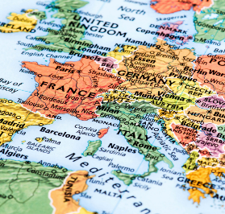 | map | A map shows you where places are.
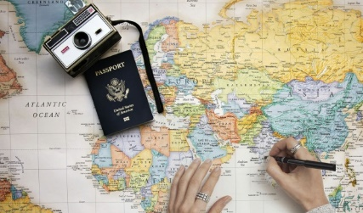 | travel | To move and visit different places.
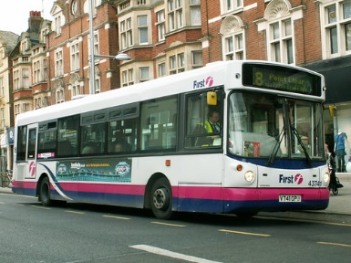 | transport | A means of travelling from one place to another.

