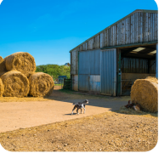 | farm | A place for growing food and keeping animals.
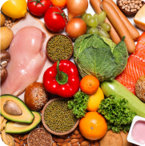 | food | We need food to grow and be healthy.
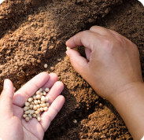 | seed | A plant grows from a seed.
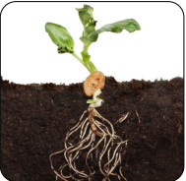 | plant | A plant grows from a seed
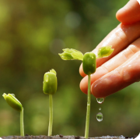 | grow | To get bigger and bigger.
 | air | We need fresh air to breathe.

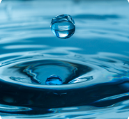 | water | Plants need water to grow.
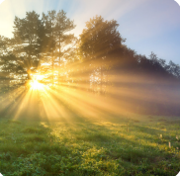 | sunlight | We get sunlight from the sun.
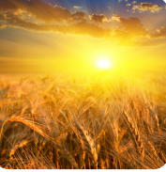 | warmth | We gat warmth from the sun.
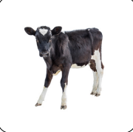 | calf | A baby cow.
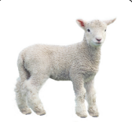 | lamb | A baby sheep.
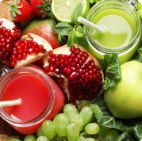 | healthy | Fruit, vegetables, water and exercise keep us healthy.

