 | adult | An adult is a grown up.
 | belief | A belief is something that you believe to be true.
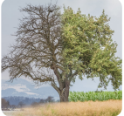 | change | The seasons change throughout the year.
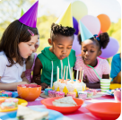 | event | Birthdays are special events.
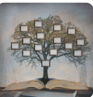 | heritage | Heritage is the traditions, objects and events from the past.
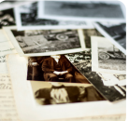 | past | Long ago – it has already happened.

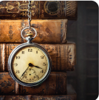 | long ago | Something that happened in the past.
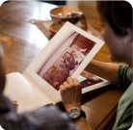 | memory | A memory is something that we can remember happening.
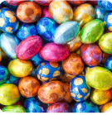 | tradition | The tradition is omething that has always been done in your family.
 | week | There are 7 days in 1 week.
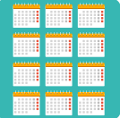 | year | There are 12 months in a year.
 | yesterday | Yesterday is the day before today.

